**PROPOSAL PROJECT**

**“ E-CANTEEN APPLICATION“**

****

**BY:**

**BRIAN SAYUDHA - 1841720158**

**EKO SETIO WIJANARKO - 1841720043**

**ARGA DIAZ PRAWIRA YUDHA- 1841720087**



**STUDY PROGRAM INFORMATICS ENGINEERING**

**DEPARTMENT INFORMATION TECHNOLOGY**

**STATE POLYTECHNIC OF MALANG**

**2021**

| logo_hitam_thok copy | KEMENTERIAN PENDIDIKAN DAN KEBUDAYAAN  **POLITEKNIK NEGERI MALANG**  **JURUSAN TEKNOLOGI INFORMASI**  **PROGRAM STUDI TEKNIK INFORMATIKA**  Jl. Soekarno Hatta No.9 Malang 65141  Telp (0341) 404424 – 404425 Fax (0341) 404420  Laman://www.polinema.ac.id Email:cs@polinema.ac.id | LOGO ISO BERWARNA |
| --- | --- | --- |

27 September 2021

Number : 001/ECT/I/2021

Attachment : -

### About : Application Offer Letter

Dear. Head of Study Program DIV Informatics Engineering

We write this letter to you on behalf of Politeknik Negeri Malang especially Jurusan Teknologi Informasi. It has come to my knowledge that you need some application that helps the canteen business in Politeknik Negeri Malang to be more optimal. It would be our pleasure to inform you that we created an “**E-Canteen Application**” that will help provide more service to students and sellers to make it more accessible and more optimal or faster. Our “**E-Canteen Application**” will increase the productivity of the Politeknik Negeri Malang canteen and even students will understand the existing technological advances.

Based on the above description. We would like to offer you our application and place an order for this application as soon as possible. we will help you to setup the application so Politeknik Negeri Malang especially Jurusan Teknologi Informasi, can increase productivity and still be able to focus on existing activities

Thus we make this offer letter, Thank you for your attention.

Regards,

Malang, …. September 2021

Team ... Project 3

### Daftar isi

### **CHAPTER 1 PRELIMINARY**

#### **Background**

Living in the current era of information technology development, provides convenience in various fields. In line with this, Human Resources (Sumber Daya Manusia) are needed to utilize their abilities in all fields and also need a tool that facilitates human work so that it is more optimal. The tools needed must be in accordance with the current era developments and even have to follow these era developments, so that humans can use these tools continuously, easily, and efficiently. Therefore, we expect a tool that can last for how many periods and face existing or future problems.

The problems that occur are of course various, with this situation we are required to continue to develop in solving existing problems. For example, trivial problems in educational support places such as the existing canteen problem.

The canteen is very important in existing schools and universities, the canteen helps students to stay enthusiastic when doing lessons because it can help improve mood and food needs. but with existing problems such as unorganized queues, payments that are quite complicated for both sellers and buyers and feelings of unfairness in terms of service are points that need to be considered. This can be detrimental to both parties and even students who are expected to take classes with enthusiasm will have an effect on this.

To facilitate the existence of canteen services in schools and universities, the e-canteen application can be used to reduce these problems, so that canteen services will be more optimal, more efficient, and can improve the mood of students to stay enthusiastic in carrying out existing learning activities.

#### **Purpose**

1. Facilitate transactions between students and sellers in the canteen.
2. Improve the development of canteen services in schools or universities with the latest technology.
3. Adding insight and knowledge about how easy it is to make transactions with online applications and other latest technologies.
4. Optimize window shopping activities so as to reduce crowds in the canteen and speed up purchases.
5. Reduce student feeling of unfairness in terms of existing services

#### **Benefit**

##### **For Students**

1. Can get used to the development of existing technology.
2. Facilitate transactions in purchasing goods and food available in the canteen.
3. Facilitate to choose any available goods or foods in the canteen.

##### **For Seller**

1. Can get used to the development of existing technology.
2. Facilitate transactions in selling goods and food available in the canteen.
3. Facilitate bookkeeping activity and display the required information to buyers

##### **For School or University**

1. Increase efficiency in terms of student learning activities at school or university.
2. Increase the quality of service in the school or University, especially the canteen

#### **Project Scope / System Offered**

The e-canteen will provide a means to make it easier for students to make transactions and order goods and food available at the school or university canteen with the latest available technology.

In this technology we can use the internet to place orders and use e-money to make existing payments. In the e-money, schools or universities can create a token that is exchanged for real money to make payments. For validation of taking orders we can use RFID (Radio Frequency Identification) so that validation becomes faster and more stable.

This application is suitable for use in companies, especially schools or universities that have very crowded canteens and need transactions quickly and accurately.

#### **Staffing**

| **Lead Engineer** | | |
| --- | --- | --- |
|  | Nama | Brian Sayudha |
| NIM | 1841720158 |
| Alamat | Jl. Danau Paniai Utara IV C7 C14, Kota Malang |
| Telepon | +6283834362007 |
| Email | [briansayudha@gmail.com](mailto:briansayudha@gmail.com) |
| **Engineer** | | |
|  | Nama | Arga Diaz Prawira Yudha |
| NIM | 1841720087 |
| Alamat | Jl. A. Yani RT-01 RW-03, Sumber Porong, Lawang, Malang |
| Telepon | +6281252110562 |
| Email | [argadiaz09@gmail.com](mailto:argadiaz09@gmail.com) |
|  | Nama | Eko Setio Wijanarko |
| NIM | 1841720043 |
| Alamat | Jl. Wolter Monginsidi RT. 32, Baru Ulu, Balikpapan Barat |
| Telepon | +6282240640884 |
| Email | [esw@gmx.com](mailto:esw@gmx.com) |

### 

### **CHAPTER 2 Budget**

#### **Business Model**

There are several uses in this e canteen application, such as :

1. E-Transaction

Buyer and Seller can do cashless payments using e-money such as mobile banking or other e-wallet. companies can also create a separate token that can be exchanged for money to make payments.

1. Online Window Shopping

Students (buyers) can make the selection of goods or food available online so there is no need for additional queues and fuss in choosing an item or food.

1. RFID Validation

Using RFID to check or validate orders quickly and accurately.

1. Merchant

Students who want to sell food or goods can be entrusted in the available canteen by willingly to become a merchant who provides periodic supplies to sellers in the canteen.

#### **Budgeting and Resources**

| **Category** | **Budget approximately in Rupiah every months** | **Resource** |
| --- | --- | --- |
| Team Salary | Rp 6.000.000,00 | For 3 person (Engineer) |
| Subscriptions | Rp 2.250.000,00 | Need for Cloud Platform, Database, Hosting, RFID , Etc. |
| Maintenance | Rp. 1.500.000,00 | For Maintenance apps |
| Update System (after finish if needed) | Rp. 3.500.000,00 | For Updating Apps to adjust the new device and tools |

### 

### **CHAPTER 3 ATTACHMENT**

#### **CV / RESUME STAFF**

* Brian Sayudha

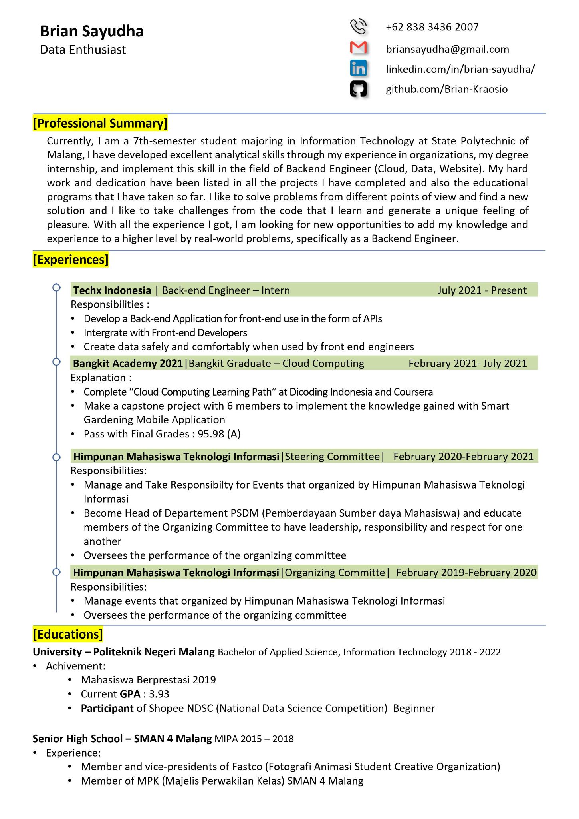

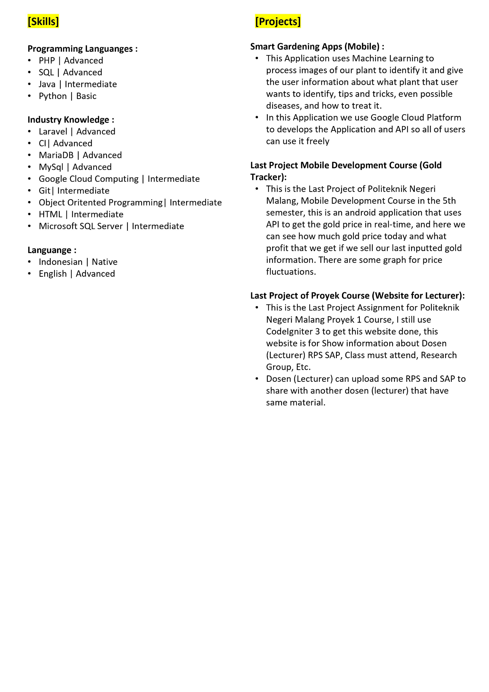

* Arga Diaz Prawira Yudha

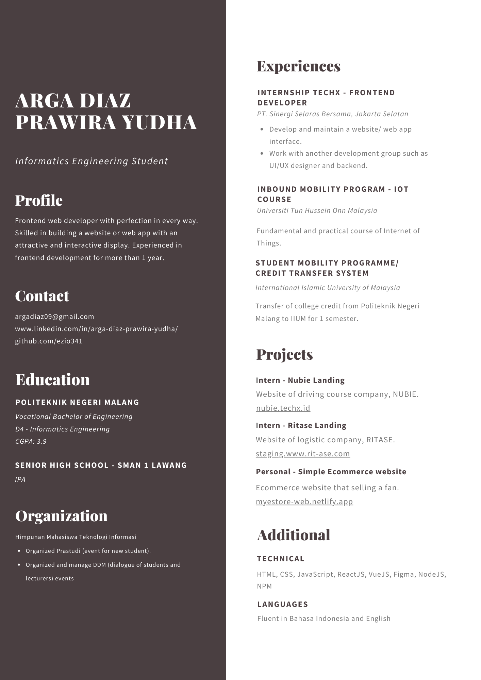

* Eko Setio Wijanarko

